PORTFOLIO RESEARCH REPORT
Corporate Treasury & Liquidity Analysis: Infosys Ltd.
Cash generation and liquidity, FY2022-23 to FY2024-25
A single-source analysis of Infosys Limited's 'Additional Information' (Annual Report 2024-25 extract)
Prepared by Bhargava C
October 2026
Data basis: one source only - Infosys Limited, “Additional Information” FY2022-23 to FY2024-25 (₹ crore).
Independent project based solely on the document cited. Not investment advice and not a description of Infosys's internal treasury decisions.

Contents
1. Executive summary
2. Introduction and project objectives
3. Company overview
4. Conceptual framework: corporate treasury and liquidity management
5. Data source and methodology
6. Financial data tables
7. Excel model methodology and formulas
8. Three-year trend analysis
9. Liquidity analysis
10. Operating cash flow and free cash flow analysis
11. Findings and discussion
12. Treasury management implications
13. Recommendations supported by the evidence
14. Limitations of the analysis
15. Conclusion
References
Appendix A. Formulas and data definitions
Appendix B. Source references by data item
Appendix C. Audit checks and unavailable items

1. Executive summary
This report asks whether Infosys Limited is generating more cash from its business, how much of that cash remains after capital expenditure, and how its liquidity position changed between FY2022-23 and FY2024-25. It uses one document only: the seven-page 'Additional Information' extract of the Annual Report 2024-25. That choice keeps every number traceable to a page, but it also limits what can be measured, and the report says so wherever it matters.
Key findings
- Cash generation strengthened. Operating cash flow was 15.7% of revenue in FY2022-23, 17.0% in FY2023-24 and 22.6% in FY2024-25. Rebuilt in rupees (approximate), that is about ₹23,042 crore, ₹26,124 crore and ₹36,836 crore.
- Cash left after capital expenditure rose faster. Capex stayed at 1.4% to 1.8% of revenue, so derived free cash flow grew from about ₹20,463 crore to ₹34,599 crore (+44.6% in FY2024-25).
- The liquidity pool grew and became more liquid. Cash plus investments rose +51.6% over two years to ₹47,996 crore, equal to 31.9% of total assets (company measure) and about 136 days of operating costs. Cash on hand was 51% of the pool in FY2024-25, up from 38%. Debt is nil.
- Not all free cash flow stayed in the pool. In FY2024-25 derived free cash flow exceeded the rise in cash and investments by about ₹26,012 crore. The source does not say where that cash went.
- Some standard ratios cannot be calculated. The current ratio, cash ratio and operating-cash-flow ratio need current assets and current liabilities, which this source does not contain. They are marked not available rather than estimated.

Table 1. Headline indicators (₹ crore; years ended 31 March)
Indicator | FY2022-23 | FY2023-24 | FY2024-25
Operating cash flow ÷ revenue (printed) | 15.7% | 17.0% | 22.6%
Operating cash flow, ₹ crore (derived, approx.) | 23,042 | 26,124 | 36,836
Capital expenditure, ₹ crore (reported) | 2,579 | 2,201 | 2,237
Free cash flow, ₹ crore (derived, approx.) | 20,463 | 23,923 | 34,599
Cash + investments, ₹ crore | 31,651 | 39,409 | 47,996
Cash and investments ÷ total assets (company) | 24.9% | 28.3% | 31.9%
Days of operating costs covered | 100 | 118 | 136
Source: Infosys 'Additional Information' 2024-25, pp.1 and 4; author's calculations. Derived rows are rebuilt from a rounded printed ratio.

2. Introduction and project objectives
Corporate treasury sits between a company's operations and its financing. It must make sure cash is available when payments fall due, keep that cash safe, and avoid holding more idle money than the business needs. Annual reports cannot show a treasury's daily work, but they do show the outcome: how much cash the business produced, how much it spent on capital items, and how large the liquid resources were at the year end.
The project answers four questions. Is Infosys generating more cash from operations over time? How much cash remains after capital expenditure? How has the short-term liquidity position changed? And what do the answers imply for corporate treasury management? The period is the three financial years ended 31 March 2023, 2024 and 2025, which gives two year-on-year comparisons.
The analysis is built as a formula-driven Excel workbook with six sheets, supported by this report and a tidy CSV dataset. A single-source design was chosen on purpose. Using one document avoids mixing figures prepared on different accounting bases, and it makes checking simple: each input in the workbook names its page.

3. Company overview
Infosys Limited is listed on the BSE and NSE in India and, through American Depositary Shares, on the New York Stock Exchange. Its registered office is in Bengaluru. The source reports Group employment of 323,578 at 31 March 2025, against 317,240 a year earlier and 343,234 two years earlier. Revenue in FY2024-25 was ₹162,990 crore, equal to USD 19,277 million, and profit after tax was ₹26,750 crore.
Three features of the data matter for treasury analysis. First, almost all revenue is classed as export revenue (96.9% in FY2024-25), which points to large foreign-currency inflows; the file does not give the currency mix. Second, the Historical Data table shows no debt in any year. Third, credit ratings are consistently strong: CRISIL AAA, Standard & Poor's A and Moody's Baa1 in all three years, with Dun & Bradstreet at 5A1. Equity was ₹96,203 crore at 31 March 2025, which is 64.6% of total assets.

4. Conceptual framework: corporate treasury and liquidity management
Liquidity means being able to meet payments as they fall due without selling assets at a loss or borrowing on poor terms. A company can be profitable and still short of cash if profit is tied up in receivables, or comfortable on paper but exposed if its cash sits in assets that cannot be turned into money quickly. Treasury management therefore looks at three things together: how much cash the business generates, how much it needs to spend, and how large and how accessible its buffer is.
Operating cash flow is the cash produced by the day-to-day business after tax and working-capital movements. Free cash flow, defined here as operating cash flow minus capital expenditure, is the cash left for dividends, buy-backs, acquisitions, lease payments and building up reserves. A company with high free cash flow and no debt has choices; a company with the same profit but weak cash conversion does not.
Standard liquidity ratios compare liquid resources with short-term obligations. The current ratio divides current assets by current liabilities, the cash ratio uses only cash, and the operating-cash-flow ratio divides operating cash flow by current liabilities. All three need a current-liabilities figure. Where it is missing, as here, other buffer measures are still useful: cash and investments as a share of total assets, and the number of days of operating costs the buffer would cover. These are cruder, and the report treats them that way.

5. Data source and methodology

5.1 Period, basis and source
All figures come from one document: Infosys Limited, 'Additional Information', a seven-page extract of the Annual Report 2024-25. Page 1 holds a ratio analysis, page 2 charts of the same ratios, page 3 an employee and revenue growth table, page 4 a twelve-year Historical Data table, and pages 5 to 7 shareholder information that is not used. The years are FY2022-23, FY2023-24 and FY2024-25, each ending on 31 March.
The ratio table states that it is based on consolidated IFRS financial statements in rupees. The growth table is headed IFRS (₹ crore). The Historical Data table is headed only 'In ₹ crore'. Figures are used exactly as printed and no adjustment between accounting bases is attempted.

5.2 Extraction and verification
44 data rows were typed into the Raw Data sheet, each with its page and table name. The workbook then runs 23 automated checks: income-statement sub-totals add up, figures that appear on two pages agree, printed ratios can be reproduced from the rupee figures, printed growth rates match the rupee series, and the two printed 'cash and investments' ratios imply the same rupee amount within rounding. All 23 checks pass. These checks prove internal consistency; they do not prove that no digit was mistyped, so every input should also be compared with the PDF.

5.3 Conventions and definitions
Three kinds of number appear. Reported figures are copied from the source. Calculated figures combine reported figures by formula, for example cash plus investments. Derived figures are the only kind not directly supported by the source: operating cash flow and free cash flow are rebuilt by multiplying revenue by the printed operating-cash-flow ratio. Because that ratio is rounded to 0.1 percentage point, each derived value carries a range of about ±₹81 crore in FY2024-25 (±0.05 pp of revenue). Derived values are shaded orange in the workbook and labelled approximate everywhere in this report.
Free cash flow is operating cash flow less the file's capital expenditure. The source does not say whether capital expenditure is cash paid or additions in the year, so the capex basis is an additional uncertainty that the rounding range does not capture.

6. Financial data tables
Table 2. Balance-sheet items relevant to liquidity
Item (₹ crore, 31 March) | FY2022-23 | FY2023-24 | FY2024-25 | Page
Cash and cash equivalents | 12,173 | 14,786 | 24,455 | p.4
Investments (current + non-current) | 19,478 | 24,623 | 23,541 | p.4
Net current assets | 31,695 | 50,638 | 54,249 | p.4
Total assets | 125,816 | 137,814 | 148,903 | p.4
Equity | 75,795 | 88,461 | 96,203 | p.4
Debt | Nil | Nil | Nil | p.4
Property, plant and equipment | 13,793 | 12,818 | 12,800 | p.4
Right-of-use assets | 6,882 | 6,552 | 6,311 | p.4
Source: Historical Data table, p.4. Current assets and current liabilities are not given separately.
Table 3. Cash flow items available from the source
Item | FY2022-23 | FY2023-24 | FY2024-25 | Page
Capital expenditure (₹ crore) | 2,579 | 2,201 | 2,237 | p.4
Operating cash flow ÷ revenue | 15.7% | 17.0% | 22.6% | p.1
Operating cash flow, derived (₹ crore) | 23,042 | 26,124 | 36,836 | derived
range: low to high (₹ crore) | 22,969–23,116 | 26,047–26,201 | 36,754–36,917 | derived
Free cash flow, derived (₹ crore) | 20,463 | 23,923 | 34,599 | derived
Dividend payout (printed) | 69.5% | 80.0% | 51.7% | p.1
The source has no cash flow statement. Derived rows multiply revenue by the printed ratio; see Section 5.3.
Table 4. Revenue and profitability
Item (₹ crore) | FY2022-23 | FY2023-24 | FY2024-25 | Page
Revenue | 146,767 | 153,670 | 162,990 | p.4
Operating profit | 30,905 | 31,747 | 34,424 | p.4
Finance cost | 284 | 470 | 416 | p.4
Profit before tax | 33,322 | 35,988 | 37,608 | p.4
Profit after tax | 24,108 | 26,248 | 26,750 | p.4
Operating margin | 21.1% | 20.7% | 21.1% | p.1
Return on equity (USD terms) | 31.2% | 32.1% | 29.0% | p.1
Day's sales outstanding (days) | 62 | 71 | 69 | p.1
Source: pp.1 and 4. Return on equity and day's sales outstanding are computed by the company in US dollars.

7. Excel model methodology and formulas
The workbook follows a simple flow. Raw Data holds the typed inputs in blue. Financial Calculations links to them in green and computes each metric by formula, with the formula written in plain words beside it. Trend Analysis turns the metrics into year-on-year changes and a formula-driven verdict on each direction. The Dashboard presents headline tiles, a summary table, six charts and observations whose numbers are built from cell values, so the text changes if an input changes. A final sheet lists the source and the audit checks.
Calculations are guarded so that a missing or zero denominator returns 'n.a.' instead of an error. The rounding tolerance and the number of days in a year are the only assumptions and sit in two blue cells. The workbook contains 588 formulas and returns no errors after a full recalculation.
Table 5. Core formulas (full list in Appendix A)
Metric | Formula | Type
Cash + investments | Cash and cash equivalents + investments | Calculated
Days of operating costs covered | (Cash + investments) ÷ [(Revenue − operating profit) ÷ 365] | Calculated
Net cash | Cash + investments − debt | Calculated
Operating cash flow | Printed OCF ÷ revenue ratio × revenue | Derived
Free cash flow | Derived operating cash flow − capital expenditure | Derived
Cash conversion | Derived operating cash flow ÷ profit after tax | Derived
Residual | Derived free cash flow − change in (cash + investments) | Derived
Capital intensity | Capital expenditure ÷ revenue | Calculated

8. Three-year trend analysis

8.1 Cash and investments
Cash and cash equivalents rose from ₹12,173 crore to ₹14,786 crore (+21.5%) and then to ₹24,455 crore (+65.4%). Investments rose +26.4% in FY2023-24 and then edged down −4.4%. Together, cash and investments grew from ₹31,651 crore to ₹47,996 crore, an increase of ₹16,345 crore or +51.6% in two years. Because the pool expanded in both years while debt stayed at nil, net cash and gross cash are the same figure.
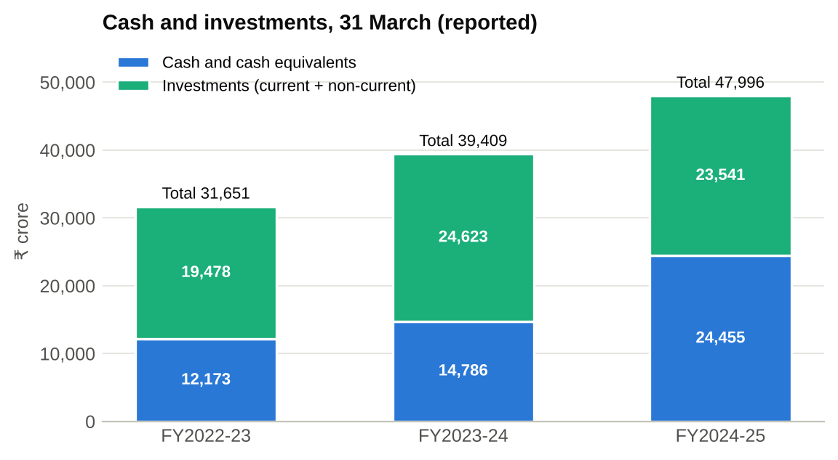
Figure 1. Cash and investments, 31 March (₹ crore). Source: p.4; author's calculations.
The composition of the pool changed in FY2024-25. Cash on hand was 37.5% of the pool in FY2023-24 and 51.0% in FY2024-25. For a treasurer, a shift from investments to cash on hand normally means more of the buffer is available immediately, although the source does not show maturities, so it cannot say how liquid the investments themselves are.

8.2 Operating cash flow, capital expenditure and free cash flow
The printed operating-cash-flow ratio rose +1.3 pp in FY2023-24 and +5.6 pp in FY2024-25. Because revenue also grew, derived operating cash flow rose faster than the ratio alone: about +13.4% in FY2023-24 and +41.0% in FY2024-25. Capital expenditure fell from ₹2,579 crore to ₹2,201 crore and was ₹2,237 crore in FY2024-25, so the capex share of revenue declined from 1.8% to 1.4%. Derived free cash flow therefore grew +16.9% and +44.6%.
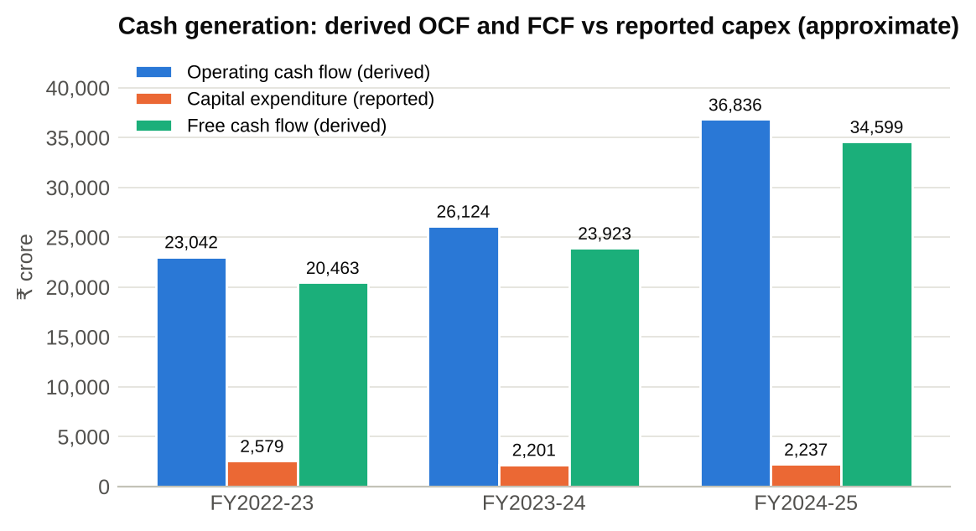
Figure 2. Derived operating cash flow, reported capex and derived free cash flow (₹ crore, approximate). Source: pp.1 and 4; author's calculations.

8.3 Net current assets, equity and finance cost
Net current assets rose from ₹31,695 crore to ₹50,638 crore in FY2023-24, a jump of +59.8%, and to ₹54,249 crore in FY2024-25. Without the components the jump cannot be explained, though it coincides with the rise in cash and investments. Equity grew +16.7% and +8.8%, lifting equity from 60.2% to 64.6% of total assets. Finance cost was ₹284 crore, ₹470 crore and ₹416 crore despite nil debt; the source does not say what it relates to, so it is noted but not interpreted.

9. Liquidity analysis
The standard short-term ratios are not available in this source. Instead, liquidity is assessed through the indicators the data does support. Table 6 sets them out, and the company's own printed ratios are shown beside the equivalent calculation from the rupee figures as a consistency check.
Table 6. Liquidity indicators
Indicator | FY2022-23 | FY2023-24 | FY2024-25
Cash + investments ÷ total assets (own) | 25.2% | 28.6% | 32.2%
Cash and investments ÷ total assets (company) | 24.9% | 28.3% | 31.9%
Cash + investments ÷ revenue (own) | 21.6% | 25.6% | 29.4%
Cash and investments ÷ revenue (company) | 21.3% | 25.4% | 29.2%
Days of operating costs covered (cash + investments) | 100 | 118 | 136
Days covered by cash and equivalents alone | 38 | 44 | 69
Net current assets ÷ revenue | 21.6% | 33.0% | 33.3%
Equity ÷ total assets | 60.2% | 64.2% | 64.6%
Operating profit ÷ finance cost | 109x | 68x | 83x
Current ratio / cash ratio / OCF ratio | n.a. | n.a. | n.a.
Own calculations include all investments; the company's measure excludes some (p.1 footnote 2), so own figures run about 0.25 to 0.33 pp higher. n.a. = not available in the source.
On every available measure, the buffer strengthened. Cash and investments rose from 24.9% to 31.9% of total assets and from 21.3% to 29.2% of revenue. The pool would cover about 100 days of operating costs in FY2022-23, 118 in FY2023-24 and 136 in FY2024-25. Operating costs here are revenue less operating profit and include non-cash items such as depreciation, so the cover is conservative in that respect. Cash and equivalents alone covered 38, 44 and 69 days.
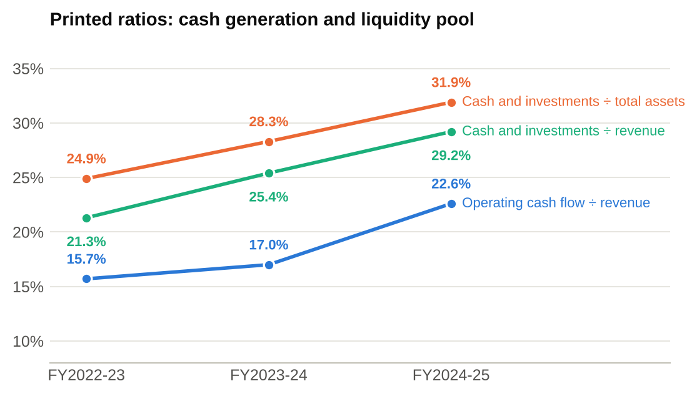
Figure 3. Printed ratios: operating cash flow and liquidity pool relative to revenue and assets. Source: p.1.
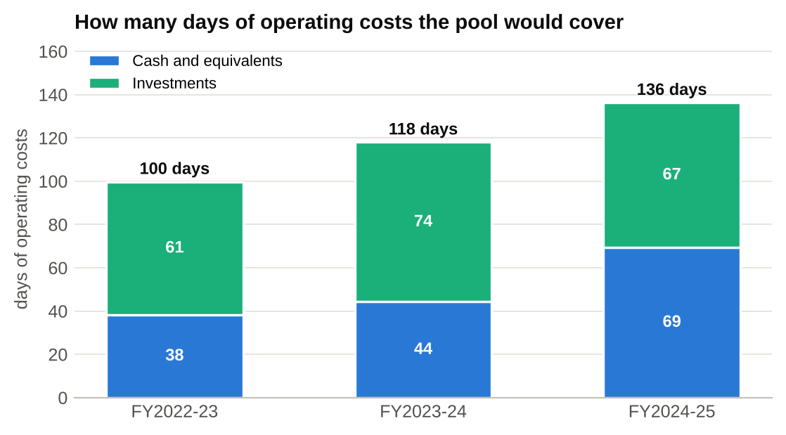
Figure 4. Days of operating costs covered by cash and by investments. Source: p.4; author's calculations.
Two cautions apply. First, the pool includes non-current investments, so it is a broad measure of financial resources and not a short-term one; the current-versus-non-current split would be needed for a proper quick-asset test. Second, the source gives no current liabilities, so the pool cannot be compared with obligations falling due within a year. Day's sales outstanding, the only working-capital indicator printed, moved from 62 to 71 and then 69 days; because it is computed in US dollars it should be read as a rough guide.

10. Operating cash flow and free cash flow analysis

10.1 How reliable is the derived operating cash flow?
Rebuilding operating cash flow from a rounded ratio is an approximation, and two kinds of error are possible. The first is rounding: the printed ratio could be 0.05 percentage point higher or lower, which moves the FY2024-25 figure by about ₹81 crore, or 0.2% of the estimate. This is small. The second is definition: the source does not say exactly how the ratio's numerator is measured, whether the same revenue figure is used, or whether capital expenditure is cash paid. These uncertainties are not quantified and could matter more than rounding. The derived values are best read as the right order of magnitude and the right direction, not as reported results.
Profit conversion shows how the two measures relate. Derived operating cash flow was 0.96x of profit after tax in FY2022-23, 1.00x in FY2023-24 and 1.38x in FY2024-25. In FY2024-25 profit after tax grew only +1.9% while derived operating cash flow grew +41.0%. A gap of that size is usually caused by timing items such as working-capital movements or tax payments, which the source does not disclose. Because the improvement may include timing effects, it would be unwise to extrapolate the FY2024-25 level.

10.2 Free cash flow
Derived free cash flow was about ₹20,463 crore, ₹23,923 crore and ₹34,599 crore, equal to 13.9%, 15.6% and 21.2% of revenue. Capital expenditure took 6.5% of operating profit in FY2024-25, against 8.3% in FY2022-23, which shows an asset-light cost base: property, plant and equipment plus right-of-use assets fell from 16.4% to 12.8% of total assets. Free cash flow was 1.29x of profit after tax in FY2024-25.

10.3 Where free cash flow went
If all free cash flow had been retained, cash and investments would have risen by the same amount. They did not. The pool rose ₹7,758 crore in FY2023-24 against derived free cash flow of ₹23,923 crore, leaving about ₹16,165 crore unexplained, and rose ₹8,587 crore in FY2024-25 against ₹34,599 crore, leaving about ₹26,012 crore. This residual is not a cash bridge. It can include dividends, share buy-backs, lease payments, acquisitions and currency or valuation effects, and the source separates none of them. The printed dividend payout ratio fell from 80.0% to 51.7% in FY2024-25, yet the residual grew, so the ratio alone cannot explain the movement.
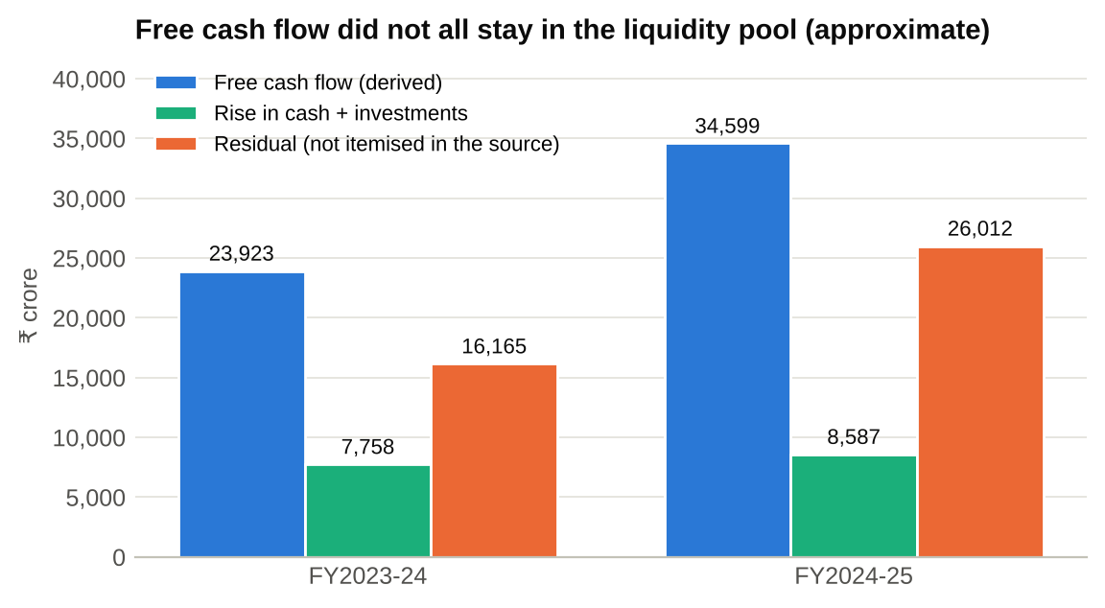
Figure 5. Derived free cash flow, rise in cash + investments, and unexplained residual (₹ crore, approximate). Source: pp.1 and 4; author's calculations.

11. Findings and discussion
Table 7. Answers to the research questions
Question | Finding from this source
Is operating cash generation improving? | Yes, in both years. OCF ÷ revenue: 15.7% → 17.0% → 22.6%. Derived OCF about ₹23,042 crore → ₹36,836 crore.
How much remains after capex? | Derived FCF about ₹34,599 crore in FY2024-25 (21.2% of revenue); capex 1.4% of revenue.
Has the liquidity buffer grown? | Yes. Cash + investments ₹31,651 crore → ₹47,996 crore; 24.9% → 31.9% of total assets.
Has it become more liquid? | Cash on hand rose from 38% to 51% of the pool in FY2024-25.
Does the company use debt? | No debt in any year; finance cost still ₹416 crore in FY2024-25 (nature not stated).
Is the improvement certain? | No. OCF and FCF are approximations; FY2024-25 may include timing effects; current liabilities are unknown.

Taken together, the evidence points to a business whose cash generation improved materially while its capital needs stayed small. The strongest conclusions are the direction of cash generation, the growth of the liquidity pool and the absence of debt, because these rest on reported or lightly derived figures. The weakest are the size of free cash flow and the explanation for the FY2024-25 jump, because they depend on rounded ratios and undisclosed timing items.
The results also guard against a common error. A rising cash balance is not by itself evidence of good treasury management. The pool grew in both years, yet derived free cash flow exceeded the build in cash by a widening margin, which means cash was also being deployed elsewhere. Whether that deployment was wise cannot be judged from this source.

12. Treasury management implications
A treasurer reading these figures would draw four implications, each stated as a possibility rather than a known fact about Infosys's policy. The first concerns buffers. A pool equal to roughly four and a half months of operating costs, with no debt, suggests short-term funding risk is low. The sensible question becomes whether the buffer is larger than needed and how efficiently it is invested, which depends on yields and maturities the source does not give.
The second concerns cash generation. Operating cash flow above profit after tax in FY2024-25 is favourable, but if it came from timing effects it may partly reverse. Treasury forecasting would normally stress-test collections and tax payments rather than assume the higher level persists.
The third concerns currency. With 96.9% of revenue classed as export revenue, foreign-currency receipts are probably large relative to rupee costs. Managing the conversion of those receipts, and the currency in which cash is held, is a core treasury task that annual figures cannot show.
The fourth concerns capital allocation. Free cash flow comfortably exceeds capex, so the main treasury decisions are about how much to return to shareholders, how much to retain and how to invest the retained pool. The residual in Section 10.3 shows that a large amount of cash was used in ways this source cannot itemise.

13. Recommendations supported by the evidence
Because this is a public-data analysis, the recommendations concern how to use the findings and how to strengthen the analysis, not instructions for Infosys.
- Obtain the missing statements. Add total current assets, total current liabilities and the cash flow statement from the full annual report. That would replace the derived rows with reported figures and allow the current, cash and operating-cash-flow ratios to be computed.
- Split investments by maturity. A current versus non-current breakdown would show how much of the pool is available within a year.
- Itemise the residual. Dividends, buy-backs, lease payments and acquisitions should be taken from the cash flow statement to explain the gap between free cash flow and the cash build.
- Test the FY2024-25 jump. Check whether working-capital or tax timing explains the rise in operating cash flow before treating it as a new run rate.
- Extend the window. More years, and later years, would show whether the pool and cash conversion are stable.

14. Limitations of the analysis
The limitations are material and are repeated in the workbook. They fall into three groups: what the source lacks, how derived figures are built, and what annual data cannot show.
- Missing statements. There is no cash flow statement, current assets, current liabilities, unearned revenue or investment note, so the standard short-term ratios are not calculated.
- Derived figures. Operating cash flow and free cash flow are rebuilt from a ratio rounded to 0.1 pp (about ±₹81 crore in FY2024-25) and from a capex figure whose basis is not stated.
- Mixed definitions. The company's cash and investments measure is non-IFRS and the two footnotes that define it differ slightly in wording. Day's sales outstanding and return on equity are in US dollars. Net current assets is not defined in the file.
- Short window. Three years give two year-on-year changes, and one of them contains an unusually large cash movement.
- No internal view. Annual statements do not show daily balances, bank or currency location of cash, credit lines, hedging, yields or forecasts.

Table 8. Public-data analysis versus an internal treasury forecast
Aspect | This analysis (public data) | An internal treasury forecast
Frequency | Annual, three data points | Daily to monthly
Direction | Backward-looking | Forward-looking (13 weeks to 12 months)
Cash detail | Totals only | By bank, currency, entity and counterparty
Inputs | One published document | Ledgers, bank feeds, payroll, tax and receivables data
Purpose | Assess trend and buffer strength | Fund payments, manage risk, optimise returns

15. Conclusion
Within the limits of one seven-page source, Infosys's cash generation strengthened between FY2022-23 and FY2024-25 and its liquidity buffer grew. Operating cash flow rose from 15.7% to 22.6% of revenue, capital spending stayed light, and cash and investments reached ₹47,996 crore with no debt. A larger share of that pool was held as cash on hand by the end of the period.
The analysis also shows what cannot be concluded. Without current liabilities, the usual liquidity ratios cannot be computed, and without a cash flow statement the size of free cash flow and the destination of the cash remain approximate. The most useful next step is to add the full financial statements, which would turn the derived rows into reported ones and complete the picture.

References
[S1] Infosys Limited. 'Additional Information' (extract of the Annual Report 2024-25), 7 pages; file infosys.pdf. Pages used: p.1 (Ratio analysis), p.3 (Employee strength and revenue growth), p.4 (Historical Data).
No other document, database or website was used for any figure in this report. The PDF should be checked against the official Infosys annual-report page (infosys.com, Investors, Reports and filings) before the figures are cited elsewhere.

Appendix A. Formulas and data definitions
Table A1. Excel implementations of the key formulas
Ref | Metric | Excel logic (words)
- A03 | - Cash + investments | - Cash and cash equivalents + investments
- A06 | - Cash + investments ÷ total assets | - A03 ÷ total assets
- B10 | - Days of operating costs covered | - A03 ÷ ((revenue − operating profit) ÷ 365)
- B07 | - Operating profit ÷ finance cost | - Operating profit ÷ finance cost
- C02 | - Capex ÷ revenue | - Capital expenditure ÷ revenue
- E02 | - Operating cash flow (derived) | - Printed OCF ÷ revenue × revenue
- E03/E04 | - Range low / high | - (ratio ∓ 0.05 pp) × revenue
- E06 | - Free cash flow (derived) | - E02 − capital expenditure
- E10 | - Cash conversion (derived) | - E02 ÷ profit after tax
- E15 | - Residual (derived) | - E06 − change in (cash + investments)

Table A2. Data definitions
Term | Meaning in this project
Reported | Number copied from the PDF, unchanged.
Calculated | Formula combining reported numbers; no estimate involved.
Derived | Rebuilt from a rounded printed ratio; approximate and shown with a range.
Not available | Item the source does not contain; never estimated.
pp | Percentage points: the arithmetic difference between two percentages.

Appendix B. Source references by data item
Table B1. Where each data item was found (all from source S1)
Ref | Item | Page | Table in PDF
R01 | Revenue | p.4 | Historical Data
R02 | Operating profit | p.4 | Historical Data
R03 | Finance cost | p.4 | Historical Data
R04 | Profit before income taxes (PBT) | p.4 | Historical Data
R05 | Provision for taxation | p.4 | Historical Data
R06 | Profit after tax (PAT) | p.4 | Historical Data
R07 | Profit attributable to non-controlling interests | p.4 | Historical Data
R08 | Profit attributable to owners of the Company | p.4 | Historical Data
R10 | Equity | p.4 | Historical Data
R11 | Debt | p.4 | Historical Data
R12 | Property, plant and equipment | p.4 | Historical Data
R13 | Right-of-use assets | p.4 | Historical Data
R14 | Capital expenditure | p.4 | Historical Data
R15 | Cash and cash equivalents | p.4 | Historical Data
R16 | Current and non-current investments | p.4 | Historical Data
R17 | Net current assets | p.4 | Historical Data
R18 | Total assets | p.4 | Historical Data
R19 | Market capitalisation - period end | p.4 | Historical Data
Q01 | Operating cash flows / revenue | p.1 | Ratio analysis
Q02 | Consolidated cash and investments / total assets | p.1 | Ratio analysis
Q03 | Consolidated cash and investments / revenue | p.1 | Ratio analysis
Q04 | Day's sales outstanding (USD terms) | p.1 | Ratio analysis
Q05 | Operating profit / revenue | p.1 | Ratio analysis
Q06 | Other income / revenue | p.1 | Ratio analysis
Q07 | Profit before tax (PBT) / revenue | p.1 | Ratio analysis
Q08 | Tax / revenue | p.1 | Ratio analysis
Q09 | Effective tax rate (tax / PBT) | p.1 | Ratio analysis
Q10 | Profit after tax (PAT) / revenue | p.1 | Ratio analysis
Q11 | Return on equity (USD terms) | p.1 | Ratio analysis
Q12 | Dividend payout | p.1 | Ratio analysis
Q13 | Market capitalisation / revenue (times) | p.1 | Ratio analysis
Q14 | Cost of sales / revenue | p.1 | Ratio analysis
Q16 | Export revenue / revenue | p.1 | Ratio analysis
Q15 | Aggregate employee costs / revenue | p.1 | Ratio analysis
S01 | Basic EPS | p.4 | Historical Data
S02 | Book value per share | p.4 | Historical Data
G01 | Revenue growth, as printed (₹ crore basis) | p.3 | Employee strength and revenue growth
G02 | PAT growth, as printed (₹ crore basis) | p.3 | Employee strength and revenue growth
T01 | Standard & Poor's | p.4 | Historical Data
T02 | CRISIL | p.4 | Historical Data
T03 | Moody's | p.4 | Historical Data
T04 | Dun & Bradstreet | p.4 | Historical Data

Appendix C. Audit checks and unavailable items
Table C1. Automated audit checks in the workbook (all three years)
# | Check | Result
1 | PBT − tax − PAT = 0 | PASS
2 | PAT − (non-controlling + owners) = 0 | PASS
3 | Revenue: p.4 table − p.3 table = 0 | PASS
4 | PAT: p.4 table − p.3 table = 0 | PASS
5 | PBT − (operating profit + other income − finance cost), ₹ croreore | PASS
6 | Operating margin: ROUND(calc, 3) − printed | PASS
7 | PAT margin: ROUND(calc, 3) − printed | PASS
8 | Effective tax rate: ROUND(calc, 3) − printed | PASS
9 | Tax ÷ revenue: ROUND(calc, 3) − printed | PASS
10 | PBT ÷ revenue: ROUND(calc, 3) − printed | PASS
11 | Revenue growth: ROUND(calc, 2) − printed | PASS
12 | PAT growth: ROUND(calc, 2) − printed | PASS
13 | Market cap ÷ revenue: ROUND(calc, 1) − printed | PASS
14 | Cash + investments ÷ total assets: own − company (pp) | PASS
15 | Cash + investments ÷ revenue: own − company (pp) | PASS
16 | Company cash & investments: ratio×assets vs ratio×revenue | PASS
17 | Cash + investments not above total assets (excess) | PASS
18 | Net current assets not above total assets (excess) | PASS
19 | Equity not above total assets (excess) | PASS
20 | Derived OCF range ordered (low ≤ central ≤ high; violation) | PASS
21 | Derived FCF not above derived OCF (excess) | PASS
22 | Debt = 0 (source shows nil) | PASS
23 | Completeness: numeric inputs on Raw Data − expected count | PASS

Table C2. Items flagged as unavailable (not estimated)
Item not in the source | Treatment in this project
Net cash from operating activities (Rs crore) | Approximated in the model from the rounded ratio and labelled DERIVED with a rounding range.
Free cash flow (reported) | Approximated as derived OCF minus the file's capital expenditure, with range.
Total current assets | Current ratio NOT calculated.
Total current liabilities | Current ratio, cash ratio, expanded cash coverage and OCF ratio NOT calculated.
Unearned revenue, trade payables and other current liability lines | Cannot analyse what drives short-term obligations.
Split of investments between current and non-current | Cash + investments is a broad measure, not a current-asset measure.
Dividends paid, buy-backs, lease payments, tax paid (Rs crore) | Uses of cash cannot be itemised; only an unexplained residual is shown.
Interest received / treasury income | Treasury yield on cash and investments NOT calculated.
Capital commitments, contingent liabilities, credit lines | Forward-looking cash calls not assessed.
Daily or intra-year cash balances and management forecasts | Out of scope for any public-data analysis.

